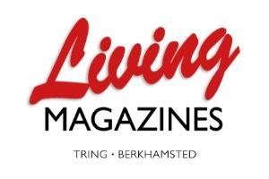
Living Magazine Booking confirmation form

Complete this form and email back to advertising@livingmags.info

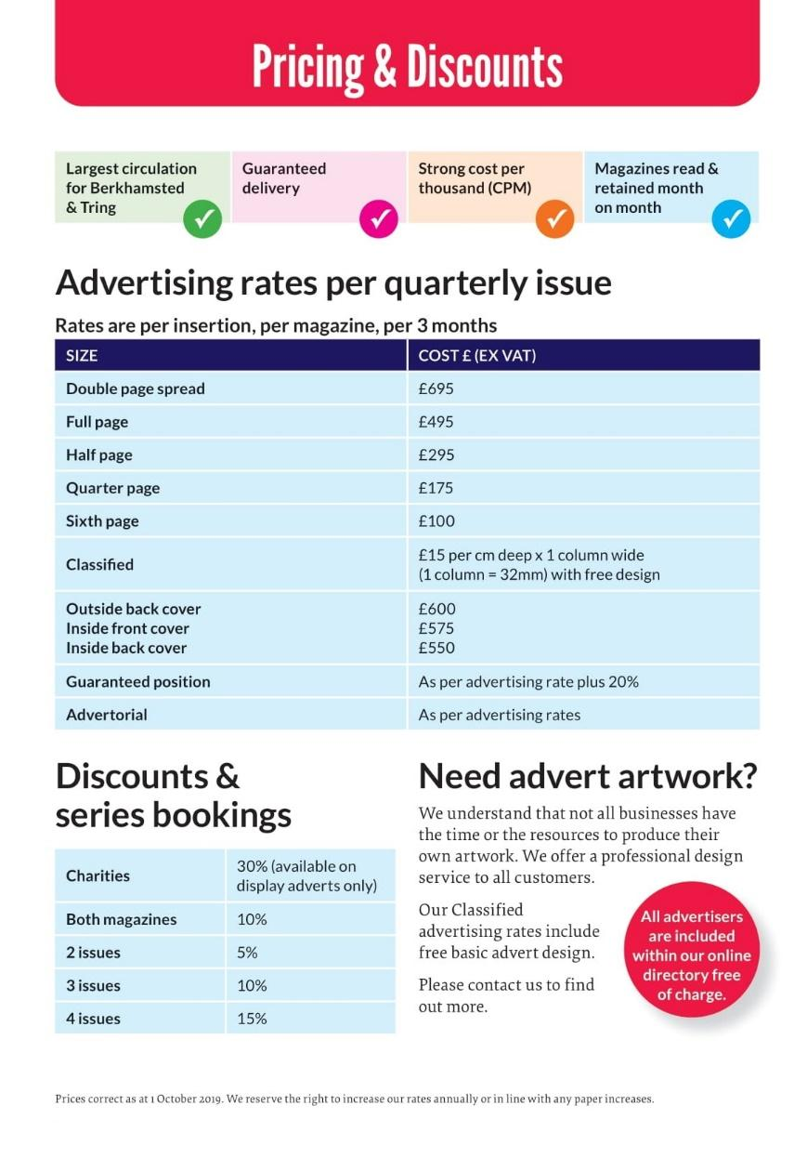
You have booked in:
Berkhamsted ☐
Tring☐
Both☐
Spring☐
Summer☐
Autumn☐
Winter☐

Advertisement size:

Position (if agreed):.....

Cost, including VAT: …………

Minus any discount:.......

Total due:.....

Please complete the following for booking and
invoicing purposes:
Name
Company name
Type of business
Postal address including postcode

Invoice address (if different)

Office Phone
Mobile Phone
Email
Invoice email address (if different)

Confirm charity status (For zero VAT, you will need to complete an additional form) ☐

Please note: Invoices are emailed from accounts@livingmags.info on the final booking date. Payment is required 14 days after invoicing.

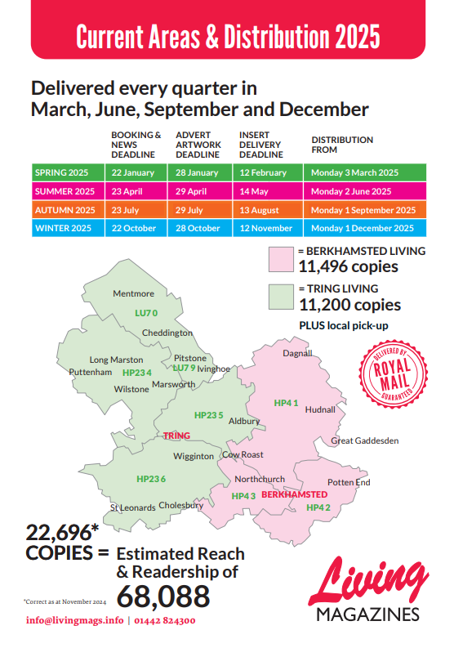
Once completed, email a copy of this form to advertising@livingmags.info

